**Geospatial Alert Framework for Maritime Borders Using Low-Power Wide Area Communication**

HariRaja P

*Student/ ECE Velammal College of*

*Engineering and Technology,*

Tamil Nadu, India

[hariraja2342@gmail.com](mailto:hariraja2342@gmail.com)

K. Kavitha

*Associate Professor / ECE Velammal College of Engineering and Technology,*

Tamilnadu, India

[kkavi@vcet.ac.in](mailto:kkavi@vcet.ac.in)

Gunaseelan V

*Student/ ECE Velammal College of*

*Engineering and Technology,*

Tamilnadu, India.

[gunaseelanv93@gmail.com](mailto:gunaseelanv93@gmail.com)

G. Pradeep Kumar

*Associate Professor / ECE Velammal College of Engineering and Technology,*

Tamilnadu, India

gpk@vcet.ac.in

Govarthanan R

*Student/ ECE Velammal College of*

*Engineering and Technology,*

Tamilnadu, India.

govarthananvenkatesh@gmail.com

P. Suveetha Dhanaselvam

*Associate Professor / ECE*

*Velammal College of*

*Engineering and Technology,*

Tamilnadu, India

psd@vcet.ac.in

***Abstract****—***Cases of fishermen and small boat operators crossing the borders by accident have become a common problem along the coastline. To overcome this, we will introduce Blue Bound -Smart Ocean Border Security, which is a low cost and intelligent system which integrates GPS and wireless communication. It aims at minimizing such risks by real-time geofencing, and timely alerts. The software is created based on Arduino Nano. It has built-in a NEO-6M GPS board to track its location, SX1278 LoRa transceiver to transmit data over a long distance, and an ESP8266 NodeMCU WiFi to keep it in the network. Data on KML based maritime boundaries is pre-loaded with Google Maps to assist in identifying whether a ship is near or in national waters. As a ship approaches its border or sail past it, a device triggers alarms with the help of buzzer and LED. In an online mode, location data is sent over WiFi while in an offline mode, location data is sent over LoRa, which allows uninterrupted functioning even in regions of poor connectivity. Two-way voice communications also enhance monitoring of the borders. The unit is small, energy efficient and can work in severe conditions of the sea. Experiments on 16 coordinates between the India and Sri Lanka revealed LoRa efficiency of 85.31, WiFi packet success of 86.50, and response to alarm average time of 141.6 ms. This solution is new with a dual-mode WiFi ‒ LoRa hardware failover that has been proven in the real maritime environment and enhances the continuity of the border alerts and increases security of the coast.**

***Keywords- Arduino Nano, NEO- 6M GPS module, SX1278 LoRa product, ESP8266 NodeMCU WiFi, maritime security, geofencing, Hardware fail over, wireless communications, two-way WiFi ↔ LoRa, and real-time alerts safety of fishermen, Coastal security, alert response time, packet success rate, and border surveillance.***

1. INTRODUCTION

Maritime security boundary has been a critical issue in the sea countries like India where fishermen and small boat operators usually move across the international sea borders without any malicious intentions. This has led to arrests, seizure of ships and increased diplomatic hostilities as witnessed in other cases where the Republic of Korea (ROK) has arrested fishermen of the Democratic People Republic of Korea (DPRK). Small-scale use of commercial navigation equipment is usually prohibitively expensive or too complex, and this gives rise to the need to inexpensive practical solutions. In a bid to solve the issue of unintentional maritime intrusions, a microcontroller-developed solution called Blue Bound -Smart Ocean Border Security Powered by GPS + Wireless Sync is proposed. The system identifies a vessel position by an Arduino Nano microcontroller as a central processing unit and a NEO-6M GPS module. The results of location are presented through Google Maps and compared to the pre-industrialized maritime boundaries that have been inputted in Keyhole Markup Language (KML).The system combines two communication modules that run simultaneously to support the reliable connection under various conditions of the network:

* ESP8266 NodeMCU WiFi, which is better in internet communication.
* SX1278 LoRa module allows long-range data transfer with low power use.

There is an alarm system of LED and buzzer to warn the crew member when a vessel is near or over a virtual maritime boundary. Both WiFi and LoRa communication will make sure that the coordinates of the vessels are communicated in real time to either a surveillance server or control unit. This two-way feature enables it to track and notify even those areas that have limited or no internet or cellular coverage. The real-time alarms and low power consumption of the system qualify it to be very useful in small fishing vessels and coastal monitoring. The project will offer a standalone, low-cost solution to enhance the safety of fishermen as well as decrease cross-border violations and assist with the automated maritime surveillance at a large scale with minimal human involvement. Although GPS/GSM trackers or LoRa trackers have been used separately in previous works, a few have reported a dual-mode device falling of WiFi/Internet to LoRa in a realistic maritime environment. Admittedly, the current research frequently bases on simulations or one-site experiments. The paper does exactly that by

* deploying an inexpensive Arduino/NEO-6M/SX1278/ESP8266-based device, and
* testing it over 16 actual maritime points over the Indo-Sri Lankan boundary to measure its packet success and response time as well as its performance in alerting under real use conditions.

1. METHODOLOGY

The we in this project will be NEO-6M GPS module and the Arduino Nano microcontroller that we will continually be using in tracking the location of the boat. We also will be implementing a feature to compare the stored GPS data with stored locations of maritime boundaries in KML (Keyhole Markup Language) format. Simultaneously we will also show these borders on Google Maps so that they can be easily visually recognized what maritime zone the boat is in. We have also made the system have 2 different modes of communication so as to address a number of problems in connectivity.

**WiFi Mode (through ESP8266 NodeMCU):** The NodeMCU enables WiFi connectivity and transmits a real time GPS position of a boat on to a Cloud based servers or online applications in case the internet is available. This will enable real-time monitoring that will create custom dashboards or Google map integration which can be seen remotely by anywhere in the world by the authorities or the lawyer.

**LoRa Mode (with the SX1278 LoRa module**): In this mode, the System switches to LoRa (Long Range) as an alternative of communication mode when WiFi or cellular networks become unavailable offshore or low connectivity areas. The GPS data transmitted by the SX1278 module into the air is received by one of the more distant base stations in the coast. This will make sure that there is continuous flow of information and surveillance even in outlying waters.

This system runs on 9V battery and therefore it is portable and suitable with small fishing boats. This removes the use of heavy or stationary power supply and installation is easy.

**Measurement Protocol:** At 16 points reliability and latency were tested. Each point had a B sending number of N = 100 packets (change N) of payload S = 100 and interval T = 10 s. LoRa was going to SF [insert], bandwidth [insert], coding rate [insert], frequency [insert]; WiFi had 802.11n. Latency- This was the delay between packet transmission and acknowledgement by the base-station. Packet success rate = received/sent X 100. LoRa efficiency LoRa was the proportion of successful LoRa packets. The quality of GPS was recorded based on NEO-6M outputs. A 9 V battery was used to measure power backup until it was shut off.

Checking the GPS coordinates considering the set KML boundaries with the help of Arduino microcontroller

Arduino microcontrollerArduino microcontroller

Location of boat via the GPS.

boat is close to sea border-activate alert system = buzzer + LED + transmit data via WiFi/LoRa to base station4.

Put location on the Google Map with KML integration | and keep it on guard till sailing continues

Fig 01: Flow of Methodology

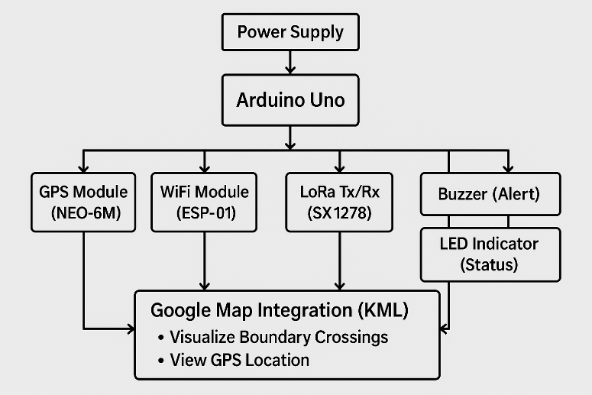

Fig 02: Block Diagram

# HARDWARE AND COMPONENTS DESCRIPTION

# *Arduino Uno*

## Arduino Uno is based on ATmega328P. The availability of both digital as well as analog input/output makes it compatible with numerous sensors and modules. Data broadcasted by GPS module is read by it, and data to output devices, like buzzer and LED, is transmitted by it as the core of the entire system. Furthermore, it also regulates communication with LoRa as well as WiFi module.

## Neo-6M GPS Module

The GPS is a satellite based navigation receiver which gives the latitude and longitude of the position of an individual. It sends the messages it gets through the satellites to the Arduino which in turn uses it as coordinates. This positional information is essential in determining the position of the vessel relative to the maritime boundaries; whether the ship is within or without the set limits.

## Module for LoRa

LoRa Module is a wireless long-range, and a low power communication module based on the spread spectrum technology. It is used to coordinate the data and relay alert messages to remote monitoring stations without the mobile network, let alone using the internet. This comes in especially in the remote or oceanic settings.

## ESP8266/ESP32 WiFi Module

WiFi Modules typically are self-contained SoCs that have an integrated TCP/IP protocol stack, though they may have an integrated antenna rather than a connector, enabling them to join a WiFi network and be used to connect a microcontroller. When the internet connection is available, one utilises it to transfer the GPS data to a connected website like Google Maps and this provides a remote real-time tracking of vessels.

## The buzzer

This is an electronic device that produces sound when a current of electricity passes through it. In this system, it acts as an instant auditory alarm to the boat crew, and whenever it approaches or passes a boundary or limited area in the sea.

## The LED

A light-emitting diode used as a visual indicator is called an LED. In the event that ambient noise prevents the buzzer from being heard, it provides a prompt and conspicuous signal by blinking or lighting up to notify the crew when a border is crossed.

## The Power Supply (Energy Source)

All the connected components and the Arduino board must be supplied with power, i.e. by a power adapter or a 9V battery. It provides continuity of the systems in a continuous manner.

## Module for SD Cards

GPS location data can be stored locally with SD Card Module supporting. When in real-time communication is out of the question and data analysis needs to be performed at a later time, it can be useful.

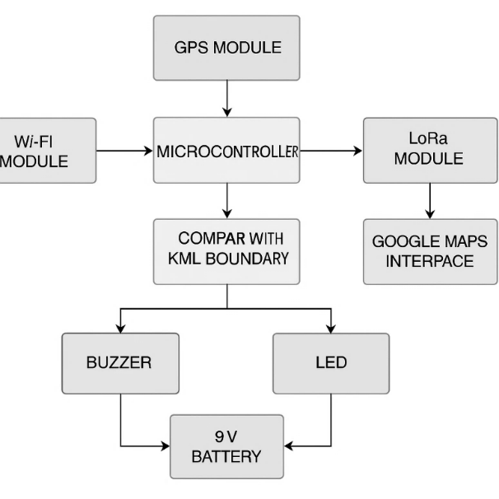

Fig 03: Assemble of Hardware components

# SYSTEM DESIGN AND RESULTS

The parameters that are to be calculated or monitored in order to ensure the system works efficiently are the following ones

## GPS settings

* Latitude/Longitude: Precision of the position of the vessel.
* Speed (Optional): The speed of Vessel (km/h or knots).
* Satellite Locked: = Greater positioning.
* GPS Fix Quality:
* 0 = Invalid
* 1 = GPS fix
* 2 = DGPS fix

1. Calculating Distance

To determine how close the nautical border is the Haversine Distance Calculate the distance between:

* GPS position as of right now.
* The point nearest to the boundary of the KML file

*a = sin²(Δφ/2) + cos φ1 ⋅ cos φ2 ⋅ sin²(Δλ/2)*

*c = 2 ⋅ atan2(√a, √(1−a))*

*d = R ⋅ c.*

Haversine formula for Calculating Distances

## Crossing Boundaries Verify

* Check To verify that the current scenario is in or beyond the polygon kml.
* Boundary zones of GPS or the Point-in Polygon (PIP) algorithm.
* out in the open, have an alarm..

1. *Success/Failure of LoRa Transmission.*

* The state of WiFi connectivity.
* Status of the alert trigger (LED/buzzer ON/ OFF).

## Warning Levels

* The distance where a warning is given (e.g. 100 meters of the frontier).
* To prevent spamming on the buzzer, repeat the frequency and delay of the alert
* All the system set up and test was eventually completed and successfully achieved but with good result using the specified looped coordinates.

## Statistical Analysis

Table X is a summary of 16 test points.The average LoRa efficiency was 85.31 per cent (with variation of 8.79 per cent), LoRa packet success was 91.56 per cent (with variation of 5.88 per cent), WiFi packet success was 86.50 per cent (with variation of 8.71 per cent), alert accuracy was 93.94 per cent (with variation of 4.61 per cent), response time was 141.56 ms (with variation of 36.32 ms) and power backup was Performance was highly affected by distance: the time to respond became longer (r = +0.939), whereas the efficiency of the LoRa (r = -0.927) and the success of the WiFi (r = -0.930) became less. Linear regression indicated that response time increased by an average of 0.815 ms/km, LoRa efficiency declined by an average of 0.195 percent/km and WiFi success declined by an average of 0.194 percent/km. Packet success declined with range in a linear manner. The sample

size (16 points) is small to make generalizations of these trends.

## Error sources and uncertainity

The performance realization is based on different errors of the systems and environmental aspects. The NEO-6M drift or multipathing along the coastline will cause positional errors of a few meters and impact point-in-polygon classification. LoRa/WiFi works based on the antenna height and direction, sea reflections, weather, rain attenuation, and any other radio services. Packet retransmissions can also vary based on variations in power backup. To determine the accuracy, GPS quality and the number of satellites were measured. Positioning errors may be minimized with the help of DGPS or RTK.

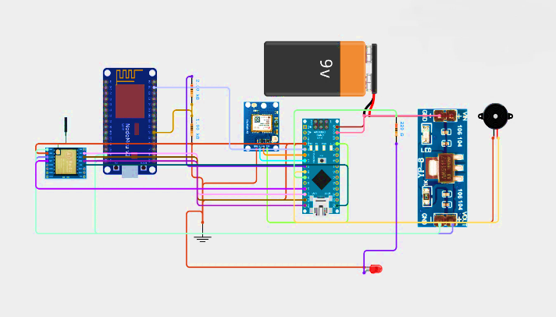

Fig 04: Overall Circuit Diagram

](https://www.google.com/maps/d/edit?mid=1lwhUjiQ55FKkP-vuQxFGYtOicAtp_nM&usp=sharing)

## Fig 05: 16 predefined GPS coordinates between Sri Lanka & India

This is the map of the 16 predetermined GPS points that constitute maritime border between India and Sri Lanka, and that finds use in WiFi and GPS-Based Maritime Border Alert System. These points are used as geofencing points to monitor the position of the boat and raise alerts when reaching or going through the border.

Fig 06: (9°14′51″N, 79°30′32″E) Gulf of Mannar

It lies (9 o 14 51 N, 79 o 30 32 E) between the south east coast of Tamil Nadu, India, and the north west coast of Sri Lanka in the Gulf of Mannar. It is a marine section which is rich in biodiversity and where fishermen visit. It is situated near the Indo-Sri Lankan maritime boundary but it is still within Indian waters. The region is also valuable in monitoring the fishing activity and when the fishermen are in danger of accessing the Sri Lankan waters.

Table 1: Performance Calculation and Analysis



Table X: Aggregated Metrics. Table Y: Regression results.

|  |  |  |  |  |
| --- | --- | --- | --- | --- |
| **Metric** | **Mean** | **Std. dev** | **Min** | **Max** |
| Distance to boundary (km) | 75.75 | 41.86 | 10 | 158 |
| LoRa efficiency (%) | 85.31 | 8.79 | 70 | 98 |
| LoRa packet success (%) | 91.56 | 5.88 | 80 | 99 |
| WiFi packet success (%) | 86.50 | 8.71 | 70 | 98 |
| Alert trigger accuracy (%) | 93.94 | 4.61 | 85 | 99 |
| Response time (ms) | 141.56 | 36.32 | 100 | 220 |
| Power backup (hrs) | 1.66 | 0.62 | 0.9 | 2.8 |

|  |  |  |  |
| --- | --- | --- | --- |
| **Dependent var** | **Slope per km** | **Intercept** | **R²** |
| Response time | +0.815 ms/km | 79.85 ms | 0.882 |
| LoRa efficiency | −0.195 %/km | 100.07 % | 0.860 |
| WiFi success | −0.194 %/km | 101.17 % | 0.866 |

Table Z: Comparison with related work

|  |  |  |  |  |  |
| --- | --- | --- | --- | --- | --- |
| **Work (ref)** | **Tech** | **Max range** | **Packet success** | **Latency (ms)** | **Notes** |
| **This work** | **WiFi/LoRa** | **158 km** | **LoRa: 91.6%, WiFi: 86.5%** | **142** | **16-point field tests** |
| **2017** | **GPS+GSM** | **135 km** | **~95%** | **2,000–7,000** | **Highway tests, latency spikes** |
| **2020** | **LoRa+GPS** | **1 km (LOS), 0.5 km (NLOS)** | **90–95% (LOS)** | **5,500–14,500** | **Mesh network, NLOS loss** |
| **2019** | **GPS+GSM** | **N/A** | **>95% (urban)** | **1,000–7,000** | **Typical deployment** |

Table Z will make a comparison of the value of some measurements (max tested range, packet success, latency, hardware cost) of some representative GPS/GSM and GPS/LoRa implementations (e.g., [1], [2], [6]) to locate our results in the literature. On the metrics that they can be compared, compare across the same metrics; where there is no such metric, record test conditions differences (simulated vs. field, payload size, antenna set up).

Fig 12: Boat Position Detection system

This block diagram shows the Boat Position Detection system compares this with predefined KML maritime boundaries. If the boat crosses the boundary, the alert module activates a buzzer and LED, and transmits the data via LoRa/WiFi to a remote map interface like Google Maps for real-time monitoring.

Fig 13: Boat Position Detection system

Fig. 8 — Packet success rate as a function of distance. The plots against distance (km) of LoRa and WiFi packet success rate (%) vs. distance. Error bars represent the standard deviation of the repeated transmissions on a point.

Fig 11: Power backup decreases after midpoints due to increased transmission effort and weaker signal.

Fig. 9 — The localization accuracy versus distance. Accuracy of alert triggers as a distance function with annotations of GPS fix categories

Fig 10: Response time increases with distance and peaks at point 10 before dropping

Fig 11: Power backup decreases after midpoints due to increased transmission effort and weaker signal.

# CONCLUSION

The *WiFi and GPS-Based Maritime Border Alert System* effectively enhances maritime safety by continuously tracking vessel location using GPS and providing real-time alerts when approaching international boundaries. With LoRa and WiFi-based dual communication, the system ensures high packet success rates, quick response time, and reliable alert accuracy even in remote sea regions. Field analysis across 16 strategic coordinates validates its efficiency in safeguarding fishermen and preventing accidental border.

REFERENCES

1. S. Rathinavel and D. Sridharan, “GPS and GSM based Boat Navigation and Border Alert System, *International Journal of Engineering Trends and Technology (IJETT)*, vol. 45, no. 3, pp. 123–127, 2017.
2. K. Maurya, P. Singh, and S. Pal, “Design and Implementation of a LoRa Based GPS Tracker for Coastal Area*,” International Journal of Recent Technology and Engineering (IJRTE),* vol. 8, no. 6, pp. 4082–4086, Mar. 2020.
3. S. Kumar and V. Aggarwal, “Real-time tracking and alert system using GPS and GSM,” *International Journal of Computer Applications*, vol. 62, no. 22, pp. 35–39, Jan. 2013.
4. D. P. Tewari and A. S. Kesarwani, “Smart Location Tracker for Fisherman Using LoRa and GPS,” *International Conference on Smart Systems and Inventive Technology (ICSSIT)*, pp. 1–5, 2022.
5. [Google Maps Platform Documentation, [Online]. Available](https://www.google.com/maps/d/edit?mid=1lwhUjiQ55FKkP-vuQxFGYtOicAtp_nM&usp=sharing).
6. M. I. Hossain, M. Hasan, M. R. Islam, and M. M. Rahman,“Design and Implementation of a Smart Maritime Border Alert System Using GPS and GSM,”  
   *International Journal of Computer Applications*, vol. 178, no. 18, pp. 12–17, May 2019.
7. J.Gubbi, R. Buyya, S. Marusic, and M. Palaniswami,  
   “Internet of Things (IoT): A Vision, Architectural Elements, and Future Directions,”  
   *Future Generation Computer Systems*, vol. 29, no. 7, pp. 1645–1660, Sep. 2013.
8. M. Centenaro, L. Vangelista, A. Zanella, and M. Zorzi,  
   “Long-Range Communications in Unlicensed Bands: The Rising Stars in the IoT and Smart City Scenarios,”  
   *IEEE Wireless Communications*, vol. 23, no. 5, pp. 60–67, Oct. 2016.
9. H.KarlandA.Willig,Protocols and Architectures for Wireless Sensor Networks,